**Name:** Yogesh Balasaheb Kumbhar. **Roll No: 56**

**Class:** Final Year B. Tech CSE **Batch:** B2

**Title: Write a program to study Intents for switching between activities.**

**Implicit Intent:**

**MainActivity.java**

package com.example.implicitintent;  
  
import androidx.appcompat.app.AppCompatActivity;  
  
import android.content.Intent;  
import android.net.Uri;  
import android.os.Bundle;  
import android.view.View;  
import android.widget.Button;  
import android.widget.EditText;  
  
public class MainActivity extends AppCompatActivity {  
 Button btn;  
 EditText txt;  
 @Override  
 protected void onCreate(Bundle savedInstanceState) {  
 super.onCreate(savedInstanceState);  
 setContentView(R.layout.*activity_main*);  
 }  
  
 public void openUrl(View view){  
 this.txt =(EditText) findViewById(R.id.*txtUrl*);  
 String url= txt.getText().toString();  
 Intent i = new Intent(Intent.*ACTION_VIEW*, Uri.*parse*(url));  
 startActivity(i);  
  
 }  
}

**activity_main.xml**

*<?*xml version="1.0" encoding="utf-8"*?>*<LinearLayout xmlns:android="http://schemas.android.com/apk/res/android"  
 xmlns:app="http://schemas.android.com/apk/res-auto"  
 xmlns:tools="http://schemas.android.com/tools"  
 android:layout_width="match_parent"  
 android:layout_height="match_parent"  
 tools:context=".MainActivity"  
 android:orientation="vertical">  
  
 <TextView  
 android:layout_width="wrap_content"  
 android:layout_height="wrap_content"  
 android:text="Implicit Intent"  
 android:paddingTop="200dp"  
 android:paddingLeft="150dp"  
 />  
 <EditText  
 android:id="@+id/txtUrl"  
 android:layout_width="match_parent"  
 android:layout_height="wrap_content"  
 android:hint="Enter Url"  
 android:paddingTop="50dp"  
 android:layout_marginLeft="50dp"  
 android:layout_marginRight="50dp"  
 />  
 <Button  
 android:id="@+id/btn"  
 android:layout_width="match_parent"  
 android:layout_height="wrap_content"  
 android:text="Submit"  
 android:layout_marginLeft="50dp"  
 android:layout_marginRight="50dp"  
 android:onClick="openUrl"  
 />  
  
</LinearLayout>

**Output:**

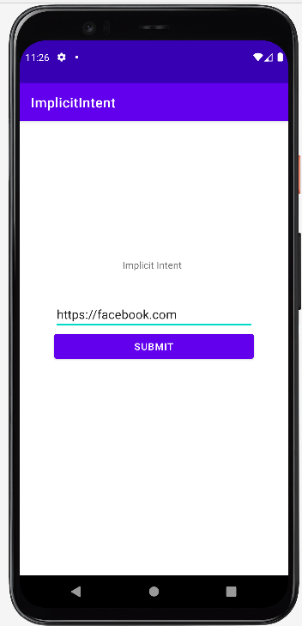 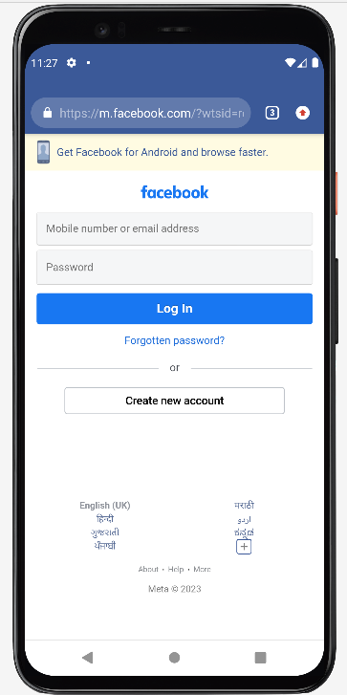

**Explicit Intent:**

**activity_main.xml**

*<?*xml version="1.0" encoding="utf-8"*?>*<LinearLayout xmlns:android="http://schemas.android.com/apk/res/android"  
 xmlns:app="http://schemas.android.com/apk/res-auto"  
 xmlns:tools="http://schemas.android.com/tools"  
 android:layout_width="match_parent"  
 android:layout_height="match_parent"  
 android:orientation="vertical"  
 tools:context=".MainActivity">  
  
 <TextView  
 android:layout_width="wrap_content"  
 android:layout_height="wrap_content"  
 android:paddingLeft="150dp"  
 android:paddingTop="200dp"  
 android:text="Explicit Intent" />  
  
 <Button  
 android:id="@+id/btn"  
 android:layout_width="match_parent"  
 android:layout_height="wrap_content"  
 android:layout_marginLeft="50dp"  
 android:layout_marginRight="50dp"  
 android:onClick="openActivity"  
 android:text="Go to second Activity" />  
  
</LinearLayout>

**MainActivity.java**

package com.example.explicitintent;  
import androidx.appcompat.app.AppCompatActivity;  
import android.content.Intent;  
import android.net.Uri;  
import android.os.Bundle;  
import android.view.View;  
import android.widget.Button;  
import android.widget.EditText;  
  
public class MainActivity extends AppCompatActivity {  
 Button btn;  
 EditText txt;  
 @Override  
 protected void onCreate(Bundle savedInstanceState) {  
 super.onCreate(savedInstanceState);  
 setContentView(R.layout.*activity_main*);  
 }  
 public void openActivity(View view){  
  
 Intent i = new Intent(MainActivity.this, SecondActivity.class);  
 startActivity(i);  
  
 }  
}

**activity_second.xml**

*<?*xml version="1.0" encoding="utf-8"*?>*<RelativeLayout xmlns:android="http://schemas.android.com/apk/res/android"  
 xmlns:app="http://schemas.android.com/apk/res-auto"  
 xmlns:tools="http://schemas.android.com/tools"  
 android:layout_width="match_parent"  
 android:layout_height="match_parent"  
 tools:context=".SecondActivity">  
 <TextView  
 android:layout_width="wrap_content"  
 android:layout_height="wrap_content"  
 android:text="This is Second activity"  
 tools:ignore="MissingConstraints"  
 android:layout_centerVertical="true"  
 android:layout_centerHorizontal="true"  
 android:background="#6CF644"/>  
  
</RelativeLayout>

**SecondActivity.java**

package com.example.explicitintent;  
  
import androidx.appcompat.app.AppCompatActivity;  
  
import android.os.Bundle;  
  
public class SecondActivity extends AppCompatActivity {  
  
 @Override  
 protected void onCreate(Bundle savedInstanceState) {  
 super.onCreate(savedInstanceState);  
 setContentView(R.layout.*activity_second*);  
 }  
}

**Output:**

